Name: Addison Kelly
Student ID: 1237585871
Date: April 21, 2026

Instructions: You should have one page (1 html file and 1 css file) of your site completed by the time you submit this. Use the following to have a written discussion about the current progress of your website. After answering the questions below, insert a screenshot of the index.html file's browser view that you have completed so far (remember, you should have one page’s browser view and a CSS file). Do NOT screenshot the HTML code, as we can’t run the code. Save the file to your asurite – Project Assignment – Project Update 1.docx file and your asurite – Project Assignment – Project Update 1.pdf file. Submit both files to Canvas.

- How do you feel your website is coming along? (10 points)

I feel that my website is coming along slowly as I have been struggling with a few technical aspects such as proper placement and sizing. That being said I’m learning much and having fun as I go and I trust that I will be doing much better for Project Update #2.

- What issues have you encountered on your first page? (4 points) How did you fix those issues, if you did? (3 points) Are there any issues still unresolved? (3 points)

I have and am now confused about how to get the background image in the header to cover a larger amount of area. I also cannot remember how to space out the horizontally aligned navigation list more.

- Tables are useful when you need to display data in an organized and structured format, such as schedules, pricing lists, or comparison charts. They help improve readability and allow users to quickly interpret information. Describe in which page you would like to use a table on your website (4 point) and what info will be included in that table (6 points). Please note: A table needs to have at least a header row + at least three data rows + at least three columns.

I feel that both the Cameras and Editors pages could use tables to organize an analysis of the different types of digital cameras and editors there are, along with organized info on each. Included info could be technical specifications, use, price range, and my recommendation.

- Where would you like to use a form on your website? (2 points) What will the form be used for? (2 points) Draw a simple sketch of how it will look (what fields will be included, any basic styling, etc.) and paste it below: (6 points) Please note: A form should have at least 4 fields.

I plan to use a form on the bottom right of the home page screen, however if this does not work with my layout I might add an entire page/html file for the form.

Here is a PowerPoint draft of how I want it to look:
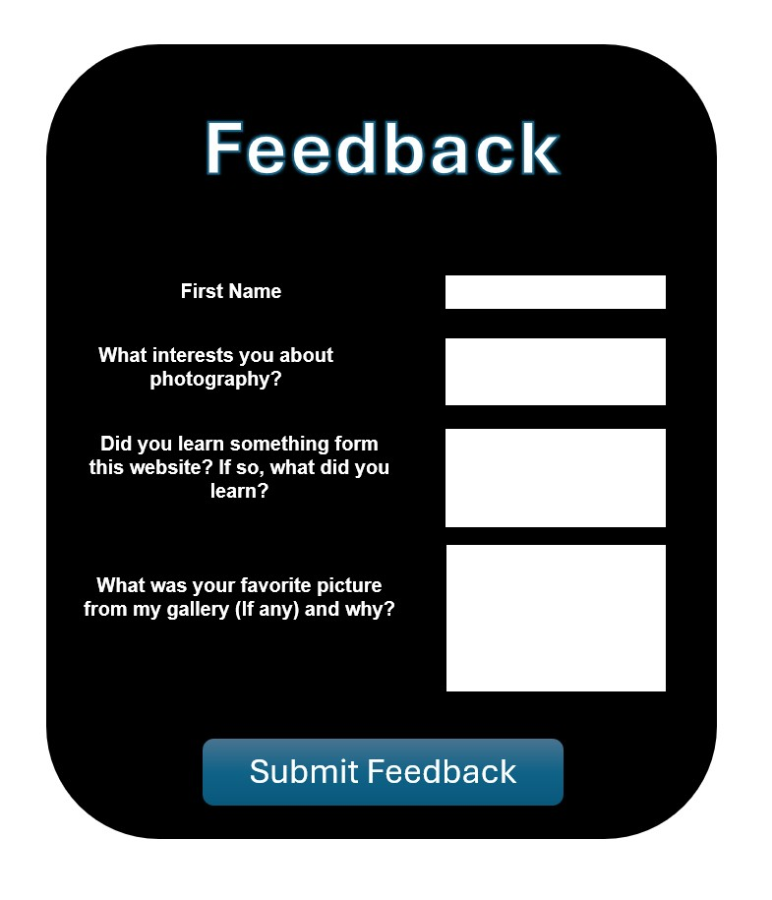

- List your project website's GitHub URL. (10 points)

akellyhappyfree.github.io

- After doing several pages, has your sitemap changed? If so, revise your previous sitemap and insert it below: (10 points).

At this time, the sitemap has not changed. It could still change as I get more into the project though (Such as add pages for links and the form, etc.

- Insert the latest wireframe below: (10 points)

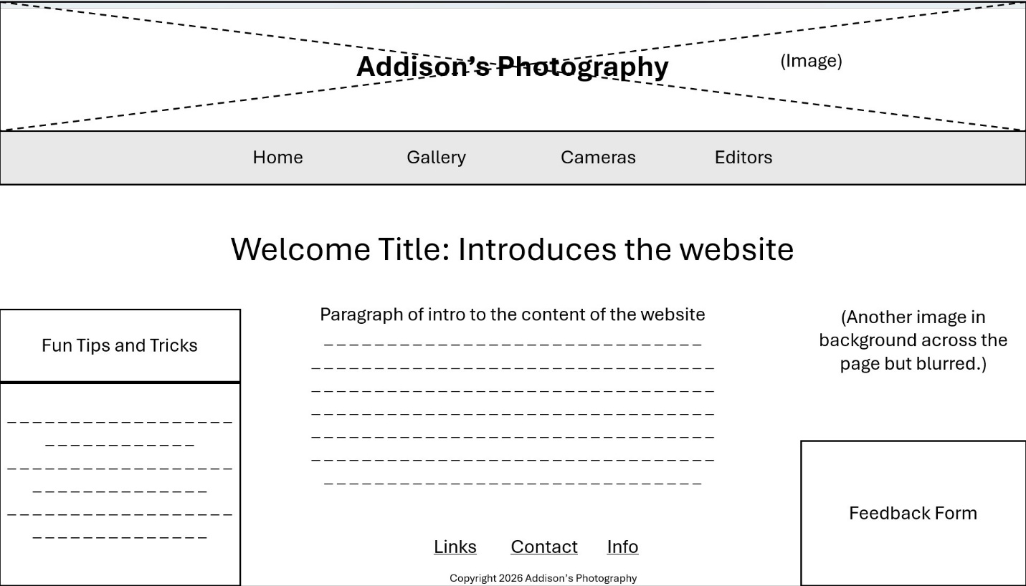

Web page browser view screenshot of Page #1 (15 points)

It’s a very rough draft but this is what I have so far:

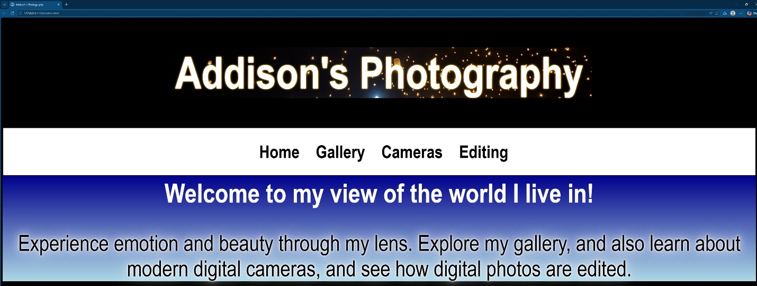

Screenshot of CSS file
Should include at least 5 selectors and 15 properties (15 points, 1 point for each)
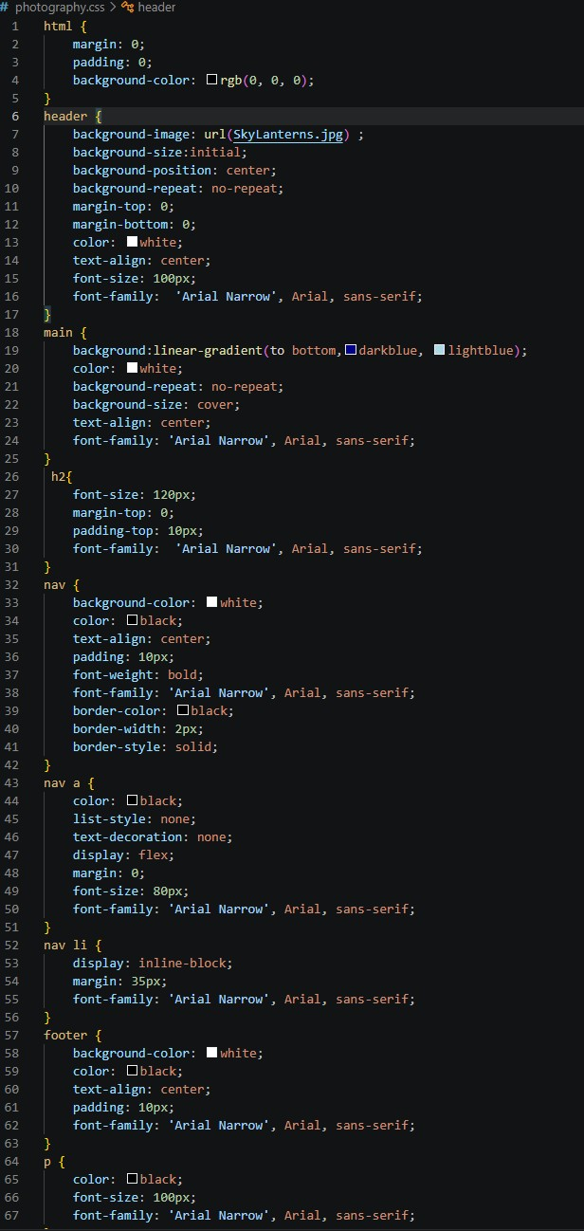
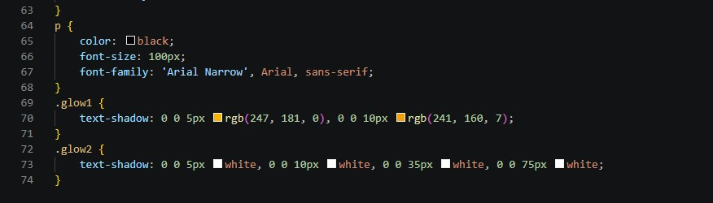

Thank You! I look forward to learning more!

